Organization model

Purpose
The organization model aims to visualize its structure by modelling and describing its division, departments, groups, team and positions.

Deliverables
Input
- Value added chain
- Process flow diagram
Output
- Organization model

Main description

Usage within the BPM methodology

Appearance and documentation

Symbols
Within a process flow a number of symbols are being used, as described in the table below.

Category | Symbol | Description
Organizational unit |  | The organizational unit describes a current existing organizational unit like a division, department or teams.
Position |  | The position is typically used within organization models to represent the formal position, e.g. account manager.  The position often combines multiple roles in different processes.
Role |  | The role is typically used within process flow diagram and describes a specific role for the given process activity.  The use of roles within the process flow diagram is advised when:  - Organization design is not a constraint.  - Processes are complex and employees fulfil multiple roles in multiple processes.

Description
All symbols are documented by their name and a short description.

Visualization
Organization chart
There are multiple ways to build and visualize the organizational structure. For simple situations the units and positions can be joined in one. For more complex structures we advise to differently and use a layered approach.
RACI within the process flow diagram

Within the process flow diagram, for every process step the RACI can be included, as displayed here for one process step.

Creation
See “Understand current organization”.
The organization model is typically prepared with the HR manager (or delegate). Afterwards it is input for creating and detailing the process flow diagram.

Related tools / techniques
- Process flow diagram
- ARIS terms of reference

Example
See chapter 1.3.2.

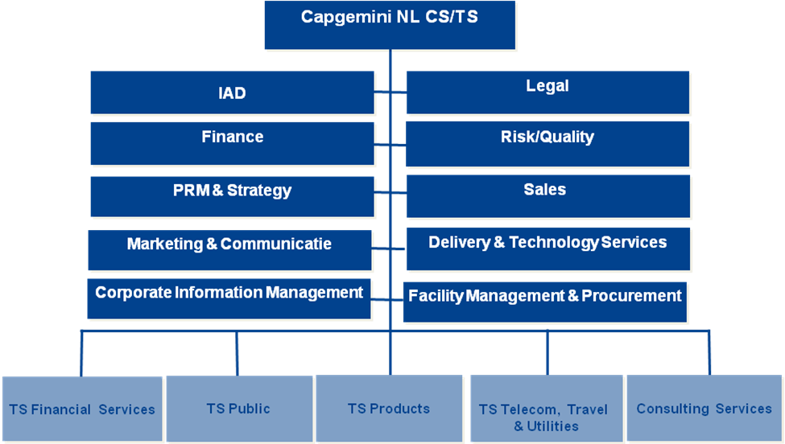
Alternative examples

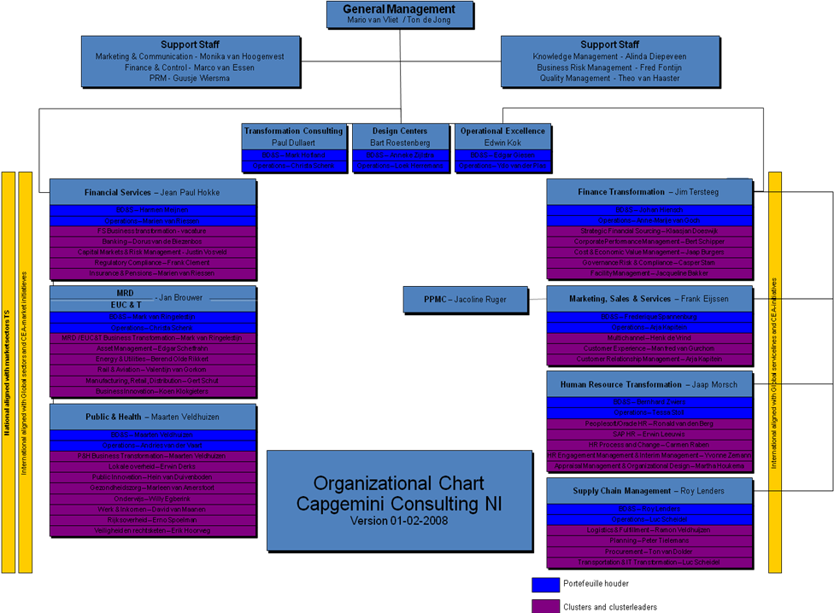

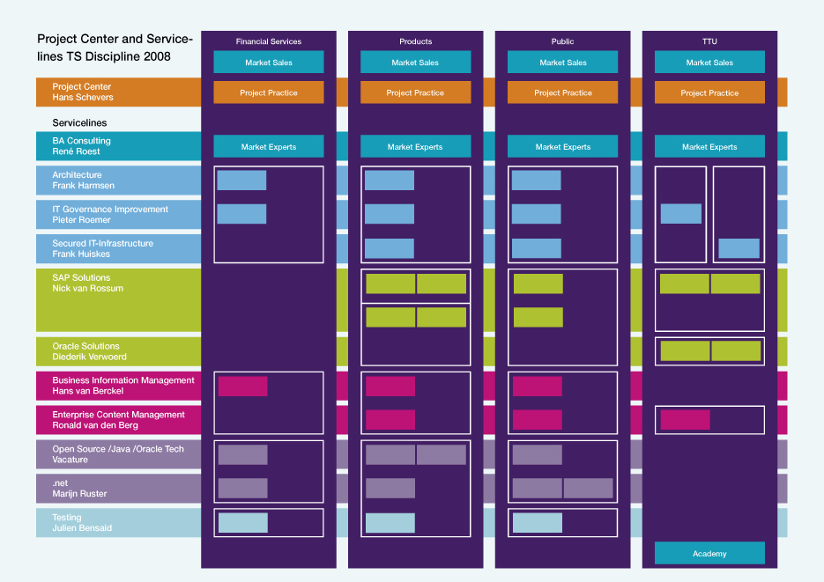

Template
Not applicable.

